Thinglink
creating a student account and sharing to Edmodo
- Go to Thinglink.com | …..Click on this button to create an account.
- Create an Edu Basic Account | SCROLL DOWN ON THIS PAGE  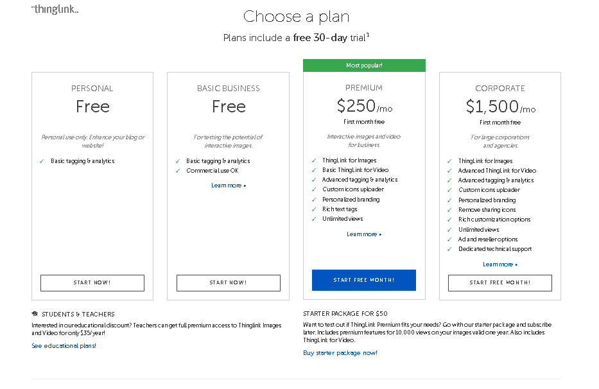  Click on the the link “See educational plans!”
- Click Create | …..to create a new thinglink
- Create, take a photography or find the photo you would like to use for the backdrop of your Thinglink.  Google Image Hint: once you have found the image you like click View Image, then right click on the mouse and save the image. | 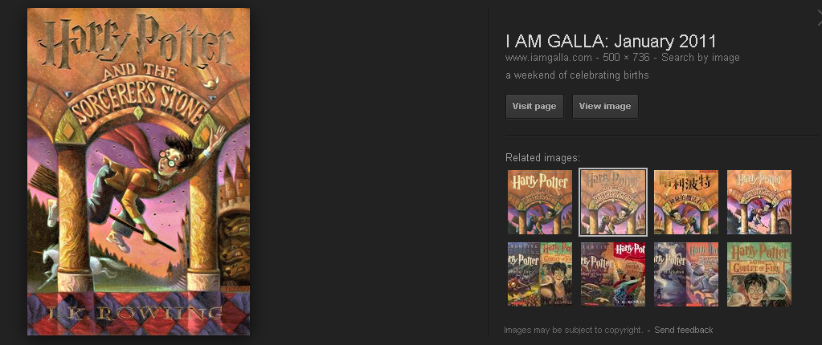

- In Thinglink, click on Upload (from Hard-Drive). If you use a URL and the image is taken down from that site your Thinglink image will no longer be present.
- In Thinglink, click on Choose images or drag and drop here
- Select your file and upload it to Thinglink by clicking Open. | 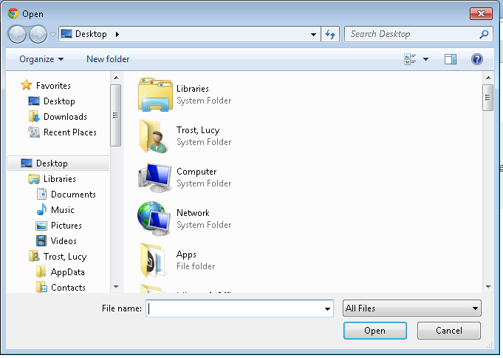
- Edit the Title of your project. Click on the image to add a tag. Remember that there are features of your tag that you can customize (color, icon, and link). click SAVE to save your work. | 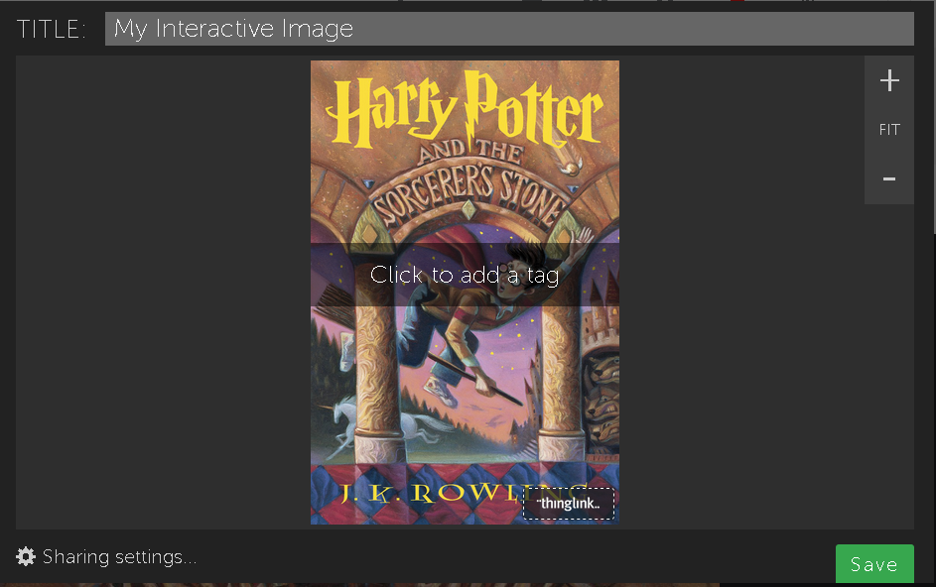

- If you want to embed video and such you can search within the editing window. Remember to click SAVE to save your work. | 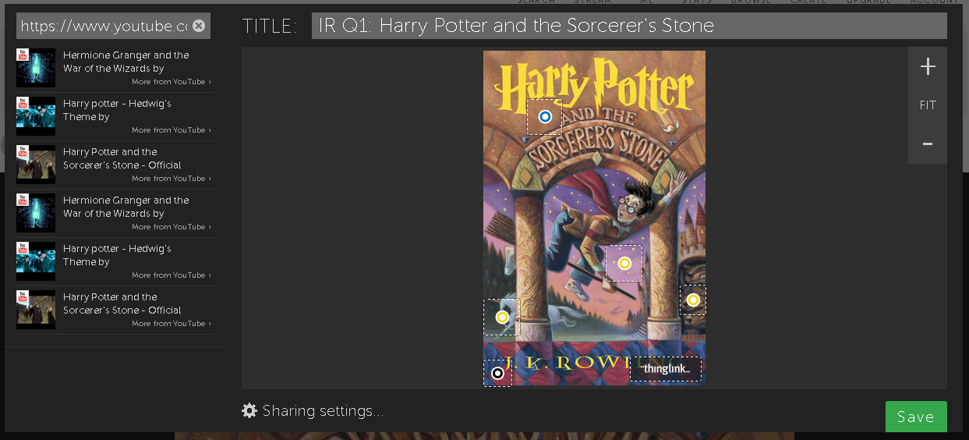
- Once you have completed your project click SAVE. Click Share this with Friends (this will appear above your image) and/OR click the SHARE button. | 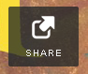
- IMPORTANT for EDMODO!!! Highlight the link in the middle of the pop-up window. Don’t try other methods.  - Copy this link by right clicking and selecting copy or push ctrl C to copy this link. | 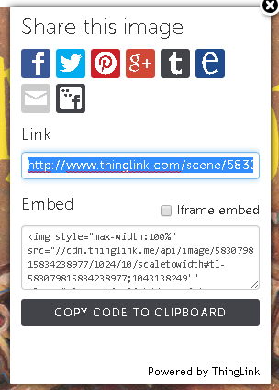
- In Edmodo, type a note to your teacher or classmate about your Thinglink Project. Select who you are posting/sending this project to and click on the link icon. | 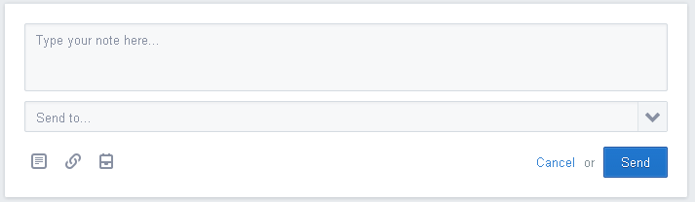
- Paste your Thinglink link into this box. Edmodo will search for your Thinglink. Give Edmodo a bit to think and once your project is found, click attach. Now students will be able to view your Thinglink as an embedded image in Edmodo.  - WARNING: Other methods do not have the same results. This was done in Google Chrome. | 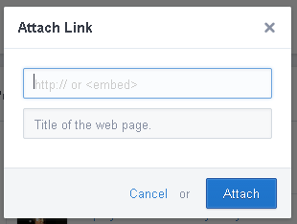
- Log-out of all applications.

